**TATA-AIG Toolbar Installation (Health, Re-newel, motor)**

Link: \\airoli_soft\d$\Process\TATA_AIG_OLD\Agent Soft

Copy “Agent Soft” in C drive

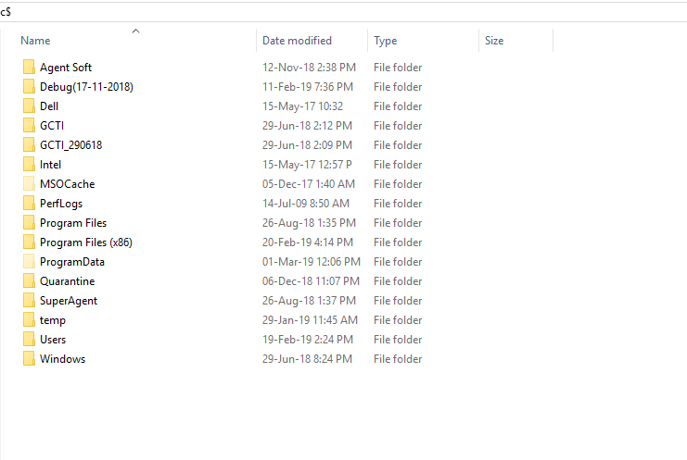

After that go to the following path of “Agent Soft”

C:\Agent Soft\CSISIP\CSISIP\CSISIP.exe.config - edit config file in notepad and change extension value “<add key="extn" value="put require extn"/>

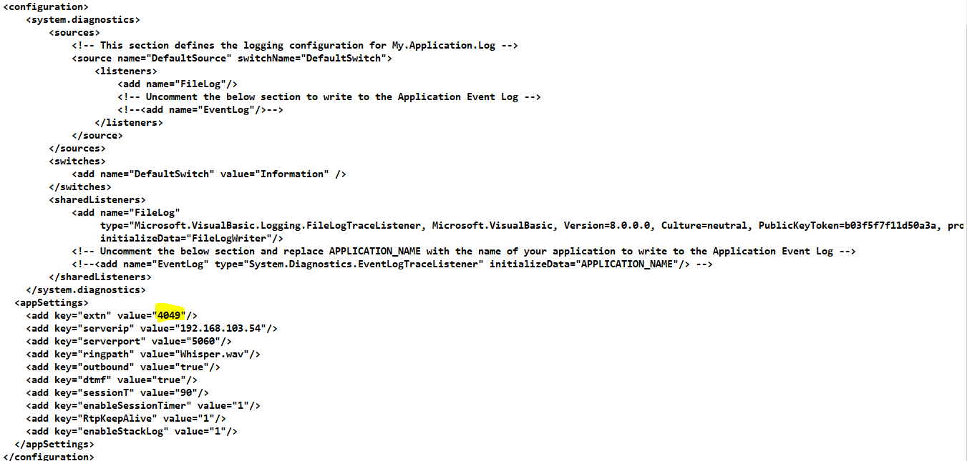

Go to the previous path “Agent Soft\CSISIP\reg.bat”

Run “reg.bat” file for register the extension value.

**Note : Complete above procedure with the admin login**

**Thank You-**